HW3

$E(p)=Np(1−p){}^{2(N−1)}$

$E'(p)=N(1−p){}^{2(N−1)}-Np2(N−1)(1-p){}^{2(N−3)}$

$E'(p)=N(1−p){}^{2(N−3)}((1-p)-p2(n-1))$

$E(p)=N\frac{1}{2n-1}(1−\frac{1}{2n-1}){}^{2(N−1)}$

$E(p)=\frac{1}{2}*\frac{1}{e}$

$E(p)=\frac{1}{2e}$

1. 3- segmented problem.
   1. Total efficiency would be pA(1-pB) + pB(1-pA)
   2. A’s throughput would be pA(1-pB)=2pB(1-pB)= 2pB- 2(pB)2.

B’s throughput would be pB(1-pA)=pB(1-2pB)= pB- 2(pB)2.

A’s throughput is not twice as large as B’s throughput.

To make pA(1-pB)= 2 pB(1-pA), we need that pA= 2 – (pA / pB).

* 1. A’s throughput is 2p(1-p)N-1, and any other node has throughput p(1-p)N-2(1-2p).

1. Length of polling round = $N(\frac{Q}{R}+d{}_{poll})$

Maximum throughput = $\frac{NQ}{N(\frac{Q}{R}+d{}_{poll})}$

Maximum throughput = $\frac{R}{(1+\frac{R*d{}_{poll}}{Q})}$

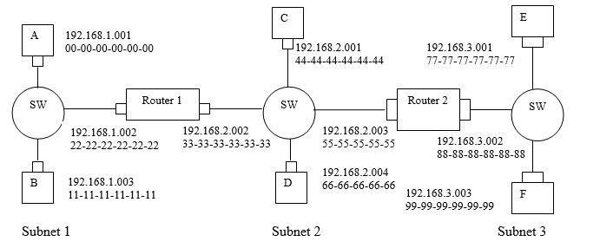

1. See Image
2. See Image
3. 5 steps
   1. Fwding table from e tells us that the datagram should be routed to go to 192.168.3.002
   2. Adapter in e creates ethernet packet w/ the address 88-88-88-88-88-88
   3. Router 2 receives packet, then extracts the datagram. Fwding table in the router indicates that this should be sent to 192.168.2.002
   4. Router 2 sends ethernet package w/ address 33-33-33-33-33-33 and source address of 55-55-55-55-55-55 via the interface with IP address 192.168.2.003
   5. Continued process until it reaches the host desiring the packet
4. ARP in e now needs to determine the MAC address of 192.168.3.002, the host E sends out a query packet from an ethernet frame broadcast. Router 2 will receive this query and will send an arp response packet to host e. This packet is carried by ethernet frame w/ an ethernet destination address of 77-77-77-77-77-77
   1. Assume dprop < S so all nodes detect the collision before completion of slots

Implementation is as follows:

Case 1: no node possession of the channel, all nodes contend for the channel

Each node transmits with the probability p

Need k-1 slots for possession of one nodes transmits for the entire frame

Case 2: Some node has possession of the channel, all remaining nodes cease from transmitting until the node possessing the channel finishes transmitting the frame.

All nodes contend for channel if one node has transmitted the frame

Channel Efficiency =

* 1. x=e[x]-1

x=

Efficiency = $\frac{k}{k+x}$

Efficiency = $\frac{k}{k+\frac{1-Np(1-p){}^{N-1}}{Np(1-p){}^{N-1}}}$

Efficiency = $\frac{k(Np(1-p){}^{N-1})}{Np(1-p){}^{N-1}(k-1)+1}$

c) Node = $N\frac{1}{N}(1-\frac{1}{N}){}^{N-1}$

x= $\frac{1-(1-\frac{1}{N}){N-1}^{}}{(1-\frac{1}{N}){}^{N-1}}$

Efficiency as node N approaches infinity

Efficiency = $\frac{k}{k+\frac{1-(1-\frac{1}{N})N^{}}{(1-\frac{1}{N}){}^{N}}}$

On applying limit

$\lim_{N→Inf}$ $(1-\frac{1}{N}){}^{N}$ = $\frac{1}{e}$

Efficiency = $\frac{k}{k+\frac{1-\frac{1}{e}}{\frac{1}{e}}}$

Efficiency = $\frac{k}{k+e-1}$

d) Efficiency = $\frac{k}{k+e-1}$

Efficiency = $\frac{1}{1+1-1}$ =1

Constant length frames = l=kRS

R = transmission rate of channel

k=big int

S = length of slot

As k is large int, it is multiple factor for the slot and transmission rate.

As efficiency approaches 1, it does not affect the length of slot, so length of the frame will become large.

1. i)

Source MAC: 00-00-00-00-00-00

Dest. MAC: 22-22-22-22-22-22

Source IP: 111.111.111.001

Dest. IP: 111.111.111.002

ii)

Source MAC: 33-33-33-33-33-33

Dest. MAC: 55-55-55-55-55-55

Source IP: 122.222.222.002

Dest. IP: 122.222.222.003

III)

Source MAC: 88-88-88-88-88-88

Dest. MAC: 99-99-99-99-99-99

Source IP: 133.333.333.002

Dest. IP: 133.333.333.003

1. Propagation time t = $\frac{L}{Propagation Delay}$

Transmission Delay = $\frac{d}{R}$

Transmission Delay = 2 \* Propagation Delay

$\frac{3000}{R}$ = $2*\frac{L}{Propagation Delay}$

$\frac{d}{R}$ = $2*\frac{L}{1.8*10{}^{3}}$

$L$ = $2*\frac{3000*1.8*10{}^{3}}{2R}$

$L$ = $2*\frac{5.4*10{}^{6}}{2R}$ = Minimum frame size of the packet

1. a)

$\frac{800}{2*10{}^{8}}$ + $4*\frac{20}{100*10{}^{6}}$

=4x $10{}^{-6}+0.8x10{}^{-6}$

=4.8 $μsec$

b)

At time t=0, both a and b transmit

At time t=4.8 $μsec$, a will detect a collision

At time t=9.6 $μsec$, the last bit of b’s aborted transmission arrives at a

At time t=14.4 $μsec$ the first bit of a’s retransmission frame will arrive at b

At time t=29.4 $μsec$ a’s packet will be completely delivered at b

c)4.8 $μsec$ +5\*100 $μsec$ = 504.8 $μsec$